Town of Prospect - Spring Cleanup
Saturday June 7th 2014 - 7:00 A.M. Curbside
Pinkerton and Sons Rubbish Removal (207) 338-8330

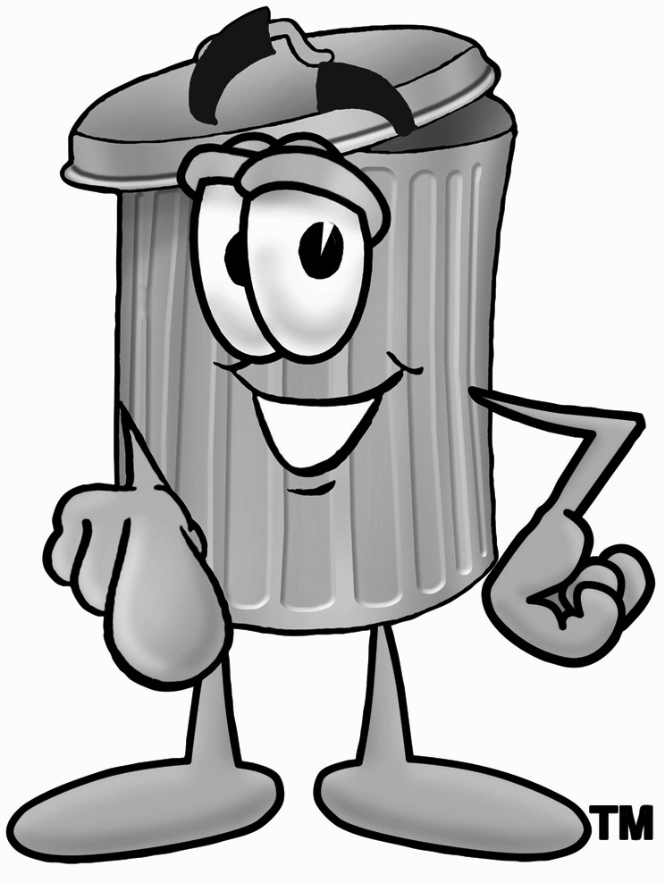
Acceptable Waste
White goods and household metals; Stoves, refrigerators, freezers, microwaves, washers and dryers. Couches, chairs, tables, desks, shelves, rugs, linoleum, carpets and pads. Porcelain sinks/toilets. Window frames (with or without glass). Mattresses/Box springs. Metal gutters and gutter pipes. Bicycle frames.
Wood
Limited to one pile no bigger than 3ft x 3ft and single pieces no longer than 3ft. For larger quantities call the above number for a dumpster (at your expense).
Unacceptable Waste
Oil of any kind or quantity. Televisions and computer monitors. Sheetrock, asphalt shingles, brush, branches, tree clippings, garden or lawn debris. Rimless tires (no bigger than 15”) can be put out with regular trash on Thursdays

ALL ITEMS must be free of liquids i.e.: petroleum, antifreeze, water, and oils.

